*AUCTION*
SATURDAY, OCTOBER 29, 2016. 1 P.M.

*Sale Location: 53415 Buck Creek RD, Atlantic IA 50022

*Tractors, Machinery, Shop, Yard Tools, Miscellaneous*

Directions: From Atlantic IA, North on N16 (Olive Street) 1 ¼ mile to Echo Rd, West on Echo Rd I Mile to Buck Creek Rd, North on Buck Creek 1 ¾ Mile, West Side.
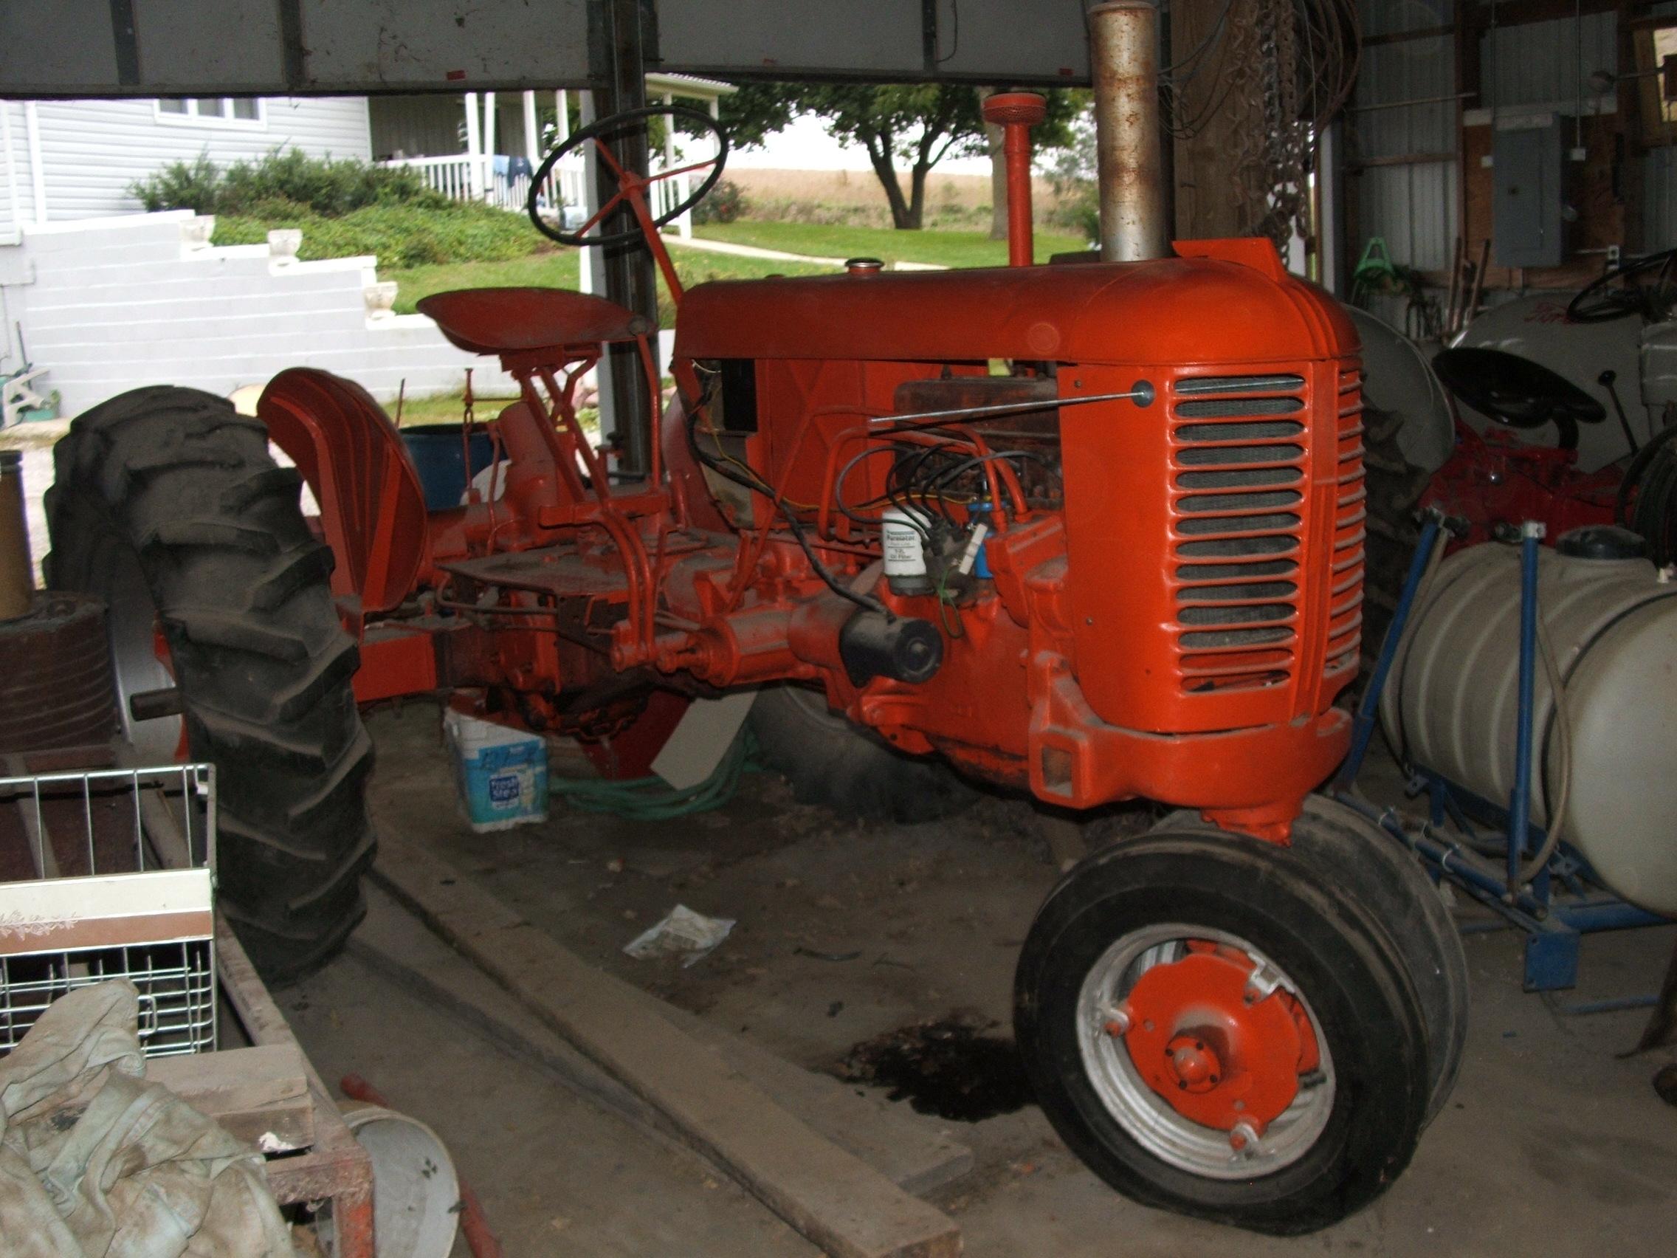
Tractors and Machinery
1951 J I Case VAC, NF, 3 Pt, Live PTO, 12 Volt, SN:5550273. Allis Chalmers C, NF. Ford Loader, Hyd Bucket. 2 Dearborn Loaders, Trip Buckets. AC Front Mount Sickle Mower. JD #205 3Pt Rotary Mower. Ford Front Mount Sickle Mower. Ford 3 Pt Dirt Bucket. 2 Wheel Trailer. Dearborn 3Pt 2 Bottom Plow. 3 Pt Flail Mower 6'. 3 Pt Sprayer. Noble 3Pt Spring Tine Cultivator 13'. Post Hole Digger.
Buzz Saw. 3 Pt Lift. Cement Mixer.
Books and Manuals
Parts Manuals 1930's, 40's, 50's, 60's, 70's, mostly Ford and Mercury. Paint Books, Shop Manuals, Collision Books, Shop Estimate Books, Microfiche Reader.
Tools, Garden, and Miscellaneous
1952 Simplicity Garden Tractor with 3 Mower Attachments, Cultivator, Planter, Tiller, and Owners Manual. 1954 Craftsman Ball Peen Hammer Set, Never Used. New Air Impact. Electric Drills and Cordless Drill, Shop Fans, Hyd Jacks, Jack Stands, Ladders, Hand Tools and Specialty Tools, Electric Motors, 3 Chain Saws, Log Chains, Sand Blaster, Hay Fork, Hog Gates, 2 Incubators, Porch Swing, Old Windows, Used Lumber, Gas Cans, Garden Hoses, Other Miscellaneous.

Dalton and Sylvia Christofferson


Dennis 'Leroy' Phillips Broker / Auctioneer 712-249-1606
Sale arranged and conducted by Property Connection Real Estate
510 Poplar St., Atlantic IA 50022
Office 712-243-4408 ~ Fax 712-243-4356 ~ phillips@metc.net
Diane Milner 712-789-0580 ~ Julie May 402-578-4019 ~ Jan Muller 712-249-1001
Not responsible for accidents or theft – Cash or Good Check

